**TrafficJam: A Look in the Rearview Mirror**

This past weekend from Oct 2nd - 4th was the TrafficJam hackathon where 150 engaged citizens formed teams and collaborated with local transportation experts, industry professionals and data experts to develop new tools and solutions for Toronto’s traffic troubles.

The City of Toronto and Evergreen CityWorks, co-hosted the 48 hour TrafficJam hackathon to determine how to use data and technology to create new solutions that will help minimize traffic congestion in Toronto and to better understand transportation issues. The beautiful space at Evergreen Brick Works stayed open for the full 48 hours and many participants found a cozy place to stay over night . We Excellent mentors were on site throughout the weekend helping out and answering participant’s questions. Representatives from Accenture, Google, Deloitte, IBM, TomTom, and the City of Toronto were among the TrafficJam mentors

During the weekend a variety of activities were available for participants if they needed a break. A nature walk was offered for participants to explore the beautiful surroundings of Ever Green Brick Works and free yoga on Sunday to help participants relax and release some stress before submission and the opening of the TrafficJam EXPO.

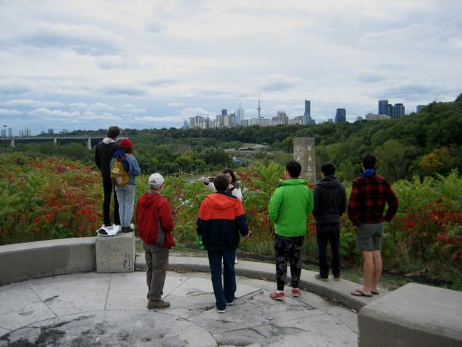

*TrafficJam participants enjoying the green surroundings at Evergreen Brick Works*

For the duration of the hackathon gourmet food was prepared and served on site for participants to enjoy. Evergreen provided food vouchers from their Farmers Market for lunch both Saturday and Sunday afternoon where participants got to pick from a wide selection of hot food made fresh at the market. On Saturday night delicious Libretto pizza was cooked in Evergreen’s on-site wood-oven for dinner.

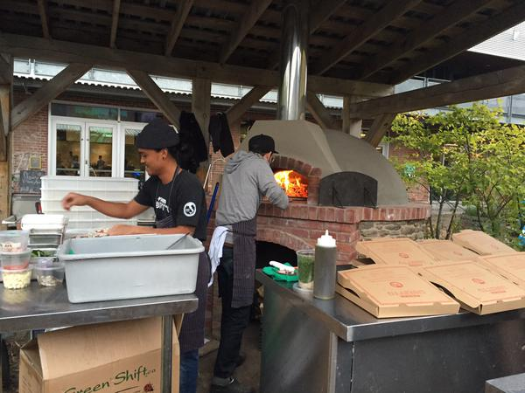

*Pizza being freshly made in the Evergreen Brick Works wood-oven*

To help keep participants awake ACCENTURE set up a gourmet Espresso Bar with its very own Barista making espressos, americanos and lattes.

After 48 hours of coding, designing and analyzing, 22 TrafficJam teams presented demos of their solutions and visualizations to peers, members of the public, and a panel of Committee Judges from Deloitte, the 407 ETR, CAA, IBM, Toronto Life, ThinkData, Civic Tech TO, Uber, Open Data Exchange, TomTom and MaRS. The committee judges reviewed each submission to narrow them down to the top 10 teams.

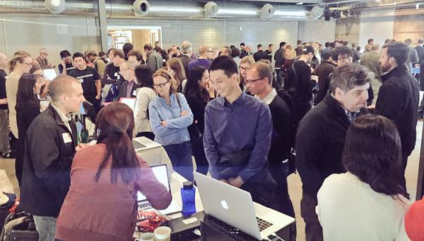

*Teams showing off their submissions at the TrafficJam EXPO*

The 3 winners were selected from the top 10 teams by the Finale Judges Deputy Premier Deb Matthews, Stephen Buckley, General Manager of Transportation Services at the City of Toronto and Geoff Cape, Co-Founder and CEO of Evergreen. They were awarded their trophies and prizes at the Awards Ceremony hosted by the hilarious Cabbie Richards.

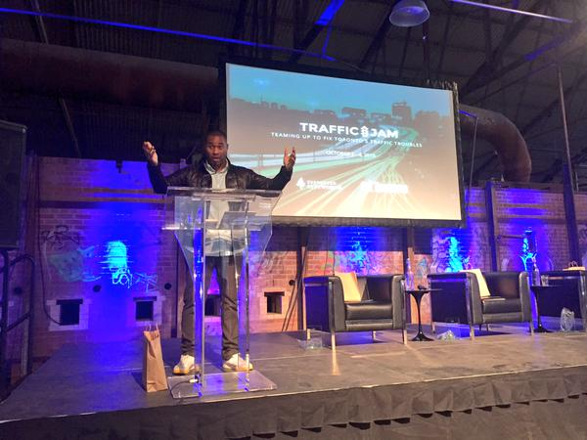

*Cabbie Richards at the TrafficJam Awards Ceremony*

The first place prize of $5,000 went to the team *TrafficJam Tacos*. Their solution identified the streets with the least reliable traffic flow and developed interesting insights into the root cause of this problem.

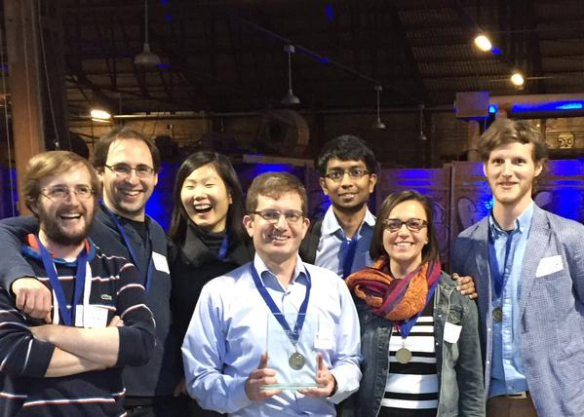

*Team TrafficJam Tacos*

The second place prize of $2,000 went to team *RueView*. This group created a traffic-forecasting tool that combined historical data and real time traffic updates to provide commuters with more accurate travel times.



*Image of the RueView TrafficJam submission*

The third place prize of $500 went to the team *Three Comma Club*. Their app and website *Walkr* looks at ways to improve walkability and the pedestrian experience throughout Toronto.

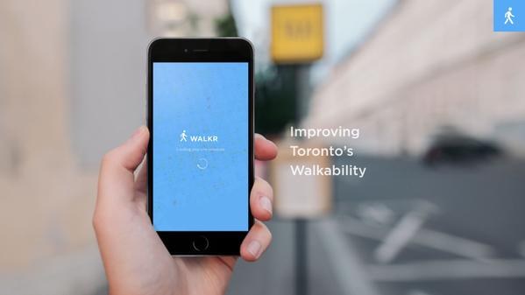

*Three Comma Club’s Walkr submission*

Congratulations to all the participants who took part in the hackathon and a big thanks to everyone that helped make this weekend possible.

